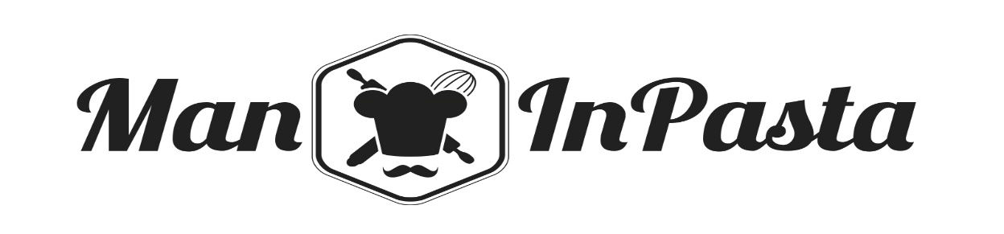
Send orders with full address
and mobile number to:
orderspasta@gmail.com

DAIRY BOX £12.90
-1Kg White Flour
-2X2 Lt Milk
-2x6 Fresh Eggs
-1KG White Sugar
-1X250 gr Butter

FRUIT BOX £14.90
-6 Lemon
-3 Orange
-4 Golden Apple
-5 Banana
-3 Avocado

VEGETABLES box £20.90
-1 Broccoli
-3 Courgette
-4 Carrot
-2 Onion
-1 Celery
-1kg Potatoes
-1 Kg Mixed Pepper
- 1 Bunch Asparagus

PASTA BOX £17.90
-500 gr Fresh SPAGHETTONI (Eggs, Gluten)
-500 gr Fresh MACCHERONCINI (Eggs, Gluten)
-500 gr Fresh VEGAN BUCATINI (Gluten)
-500 gr Fresh VEGAN CASERECCE (Gluten)

VEGAN PASTA BOX £18.90
-500 gr Fresh VEGAN BUCATINI (Gluten)
-500 gr Fresh VEGAN CASERECCE (Gluten)
- 500 gr ORG Tomato Sauce
- 500 ml Extra Virgin Olive Oil
- 300 gr Quick-Polenta
-1Kg Fine Sea Salt

MEDIUM BOX £36.90
-500 gr Fresh SPAGHETTONI (Eggs, Gluten)
-500 gr Fresh MACCHERONCINI (Eggs,Gluten)
-500 gr Fresh VEGAN BUCATINI (Gluten)
- 500 gr ORG Tomato Sauce
-200 gr ORG Bolognese sauce
- 130 gr ORG Basil Pesto
-500 gr ORG Brown Rice
- 500 ml Extra Virgin Olive Oil
- 100 gr ORG Grated Parmesan
- 300 gr Quick-Polenta
-1 Kg Fine Sea Salt

LARGE BOX £53.90
-500 gr Fresh SPAGHETTONI (Eggs, Gluten)
-500 gr Fresh MACCHERONCINI (Eggs, Gluten)
-500 gr Fresh VEGAN BUCATINI (Gluten)
- 500 gr ORG Tomato Sauce
-200 gr ORG Bolognese sauce
- 130 gr ORG Basil Pesto
-500 gr ORG Brown Rice
-500 gr ORG Arborio Rice
-400gr ORG Wildflower Honey
- 500 ml Extra Virgin Olive Oil
- 100 gr Grated Parmesan
-160 gr Tuna in Olive Oil
- 300 gr Quick-Polenta
-1Kg Fine Sea Salt
-250 gr Coffee

WATER SAN PELLEGRINO /PANNA £15.90
-Case of 24x500ml

*Please note that for orders under £30 a £5 delivery fee will be applied

We would like to ensure you that during this time we are trading in line with the government advice

